**DEVOPS – DOCKER**

Spring project for Services are pushed to below repository.

* <https://github.com/arunbalajii/service_assignment.git>

Codes are dockerized and pushed to hub.

To pull them to local

* docker pull arunvig/trans_ser:1
* docker pull arunvig/user_ser:1

Environment variables for mongodb credentials are already set during build so it is not required to provide values during run.

User Service runs in port 8080

Trans Service runs in port 8081

* docker run --name User_Service -p 8080:8080 arunvig/user_ser:1
* docker run --name Transaction_Service -p 8081:8080 arunvig/trans_ser:1

Once the service is running, they can be reached using below collection



**Steps followed for the dockerisation**

Generating Jar file using - Maven clean install

Created two docker files for two different services with environment variable and arguments for which values are passed during build.

docker images

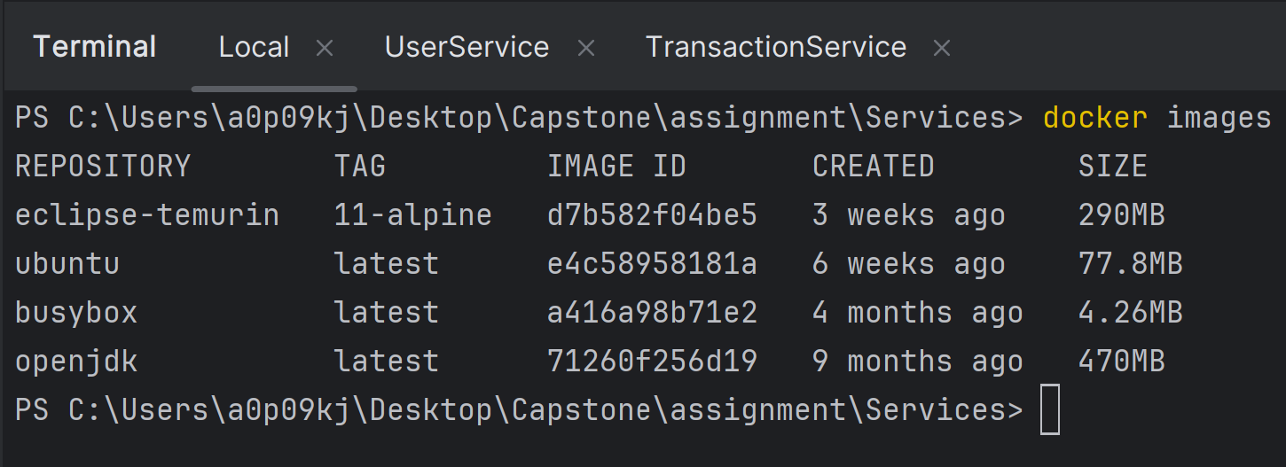

Building new docker image for the spring application user_service and transaction_service

password is masked here

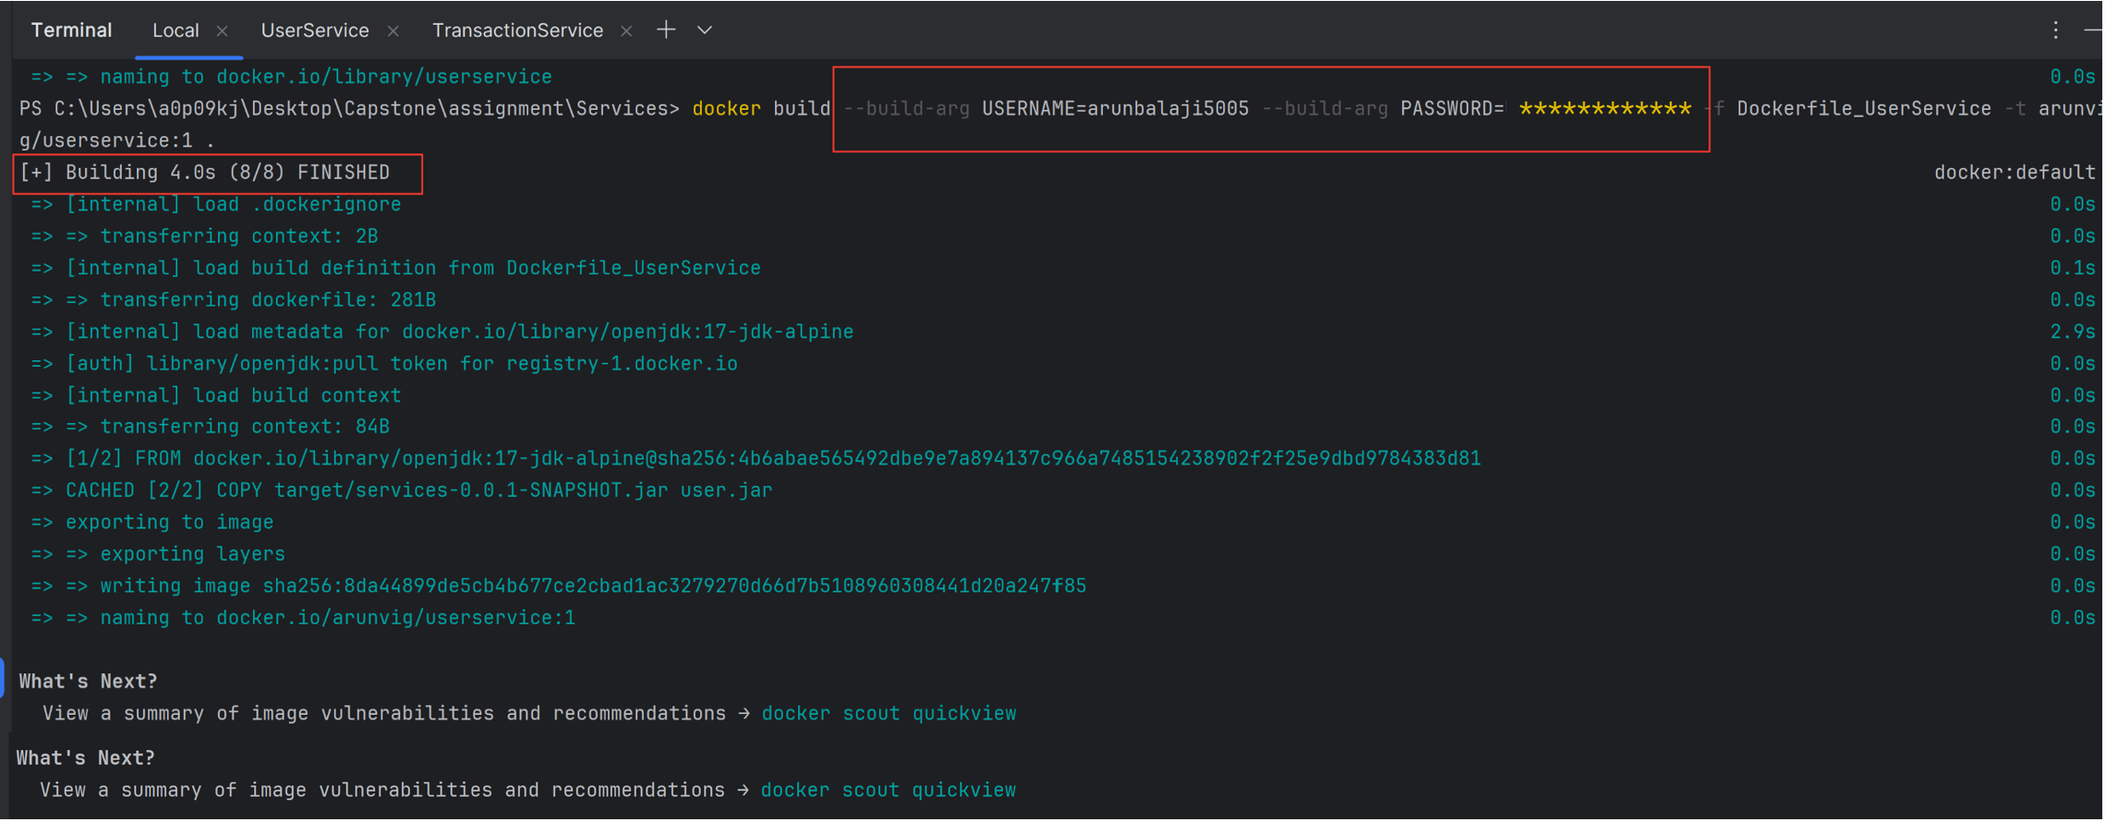

Two images got created for both User and Transaction services

Running the images in two different ports to check the functionality.

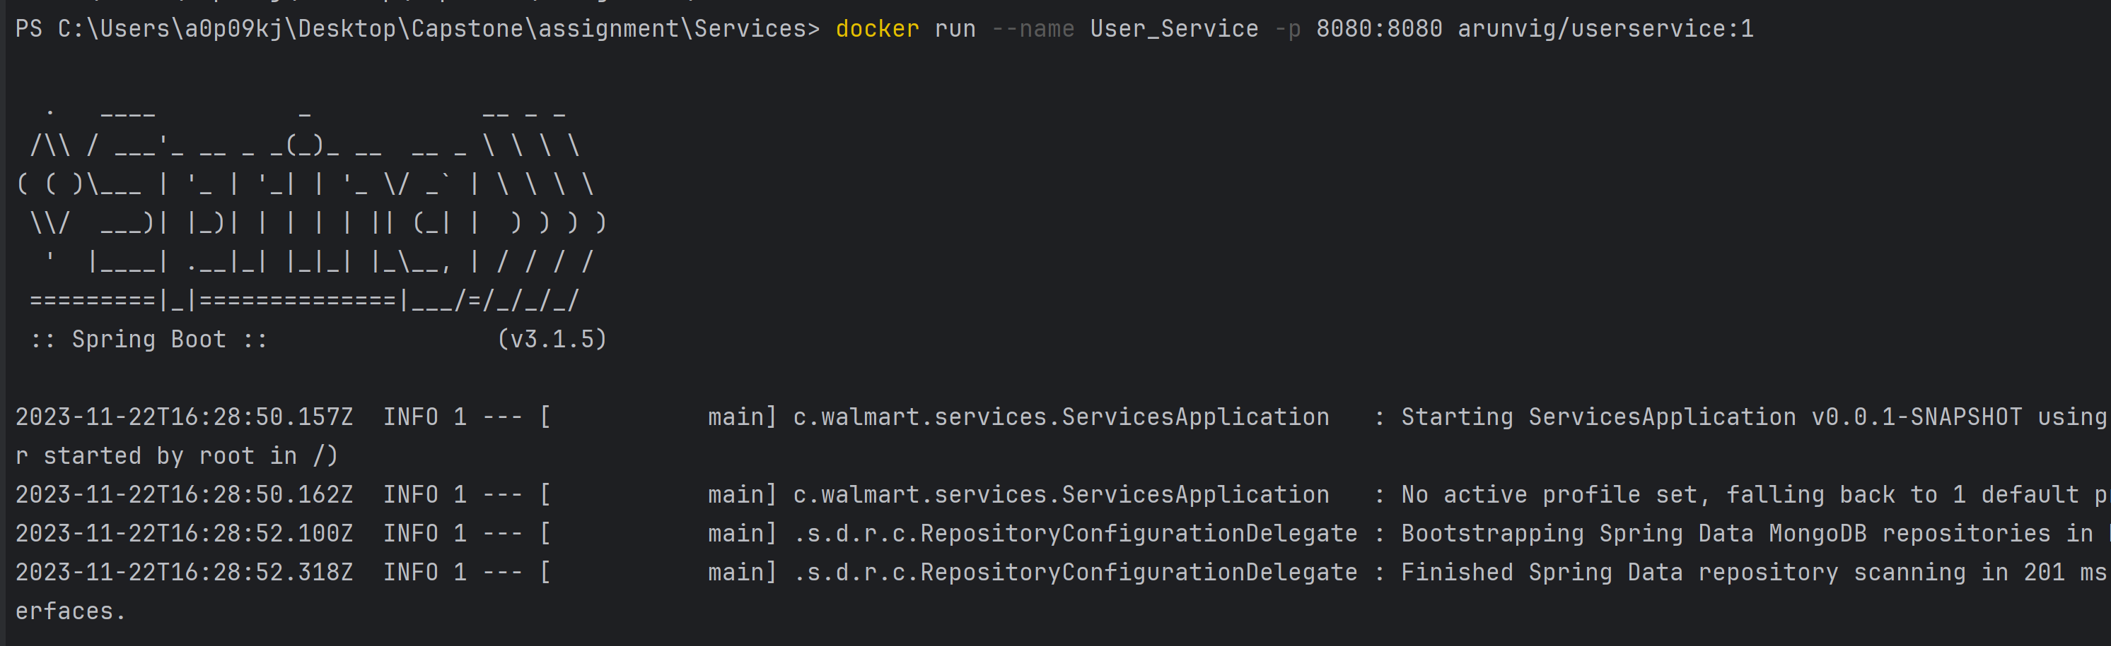

Current running processes



Below are the environment variables in container for the Transaction service where username and passsword values are set during build.

**Steps to push the images to hub**

Both the images are pushed to hub for public access

docker push arunvig/trans_ser:1

docker push arunvig/user_ser:1

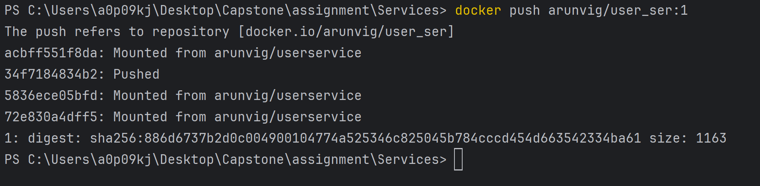

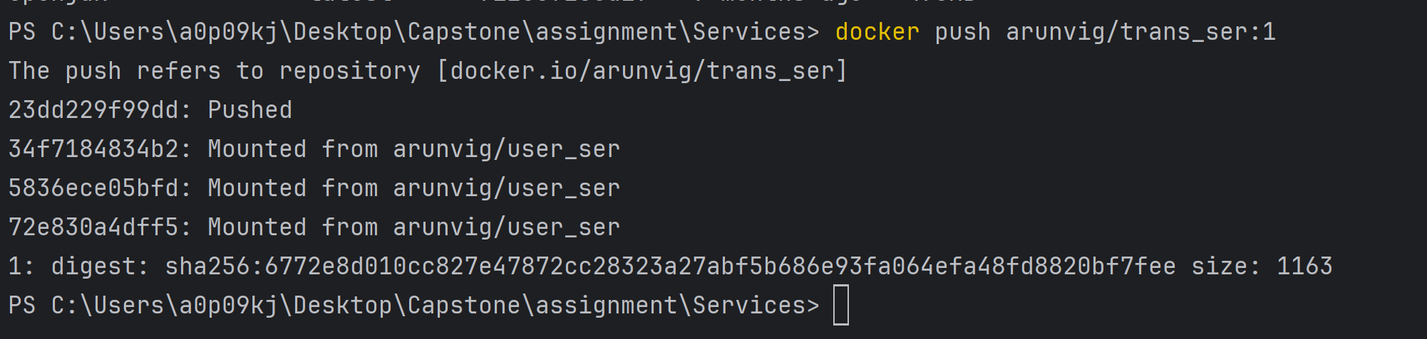

User Service is running in port – 8080

Transaction Service is running in port - 8081

Images pushed to hub

docker pull arunvig/trans_ser:1

docker pull arunvig/user_ser:1

